Assignment -3

|  |  |
| --- | --- |
| Assignment Date | 01 October 2022 |
| Student Name | Santhosh . R |
| Student Roll Number | 312319104146 |
| Maximum Marks | 2 Marks |

**Create a Bucket in IBM object storage**

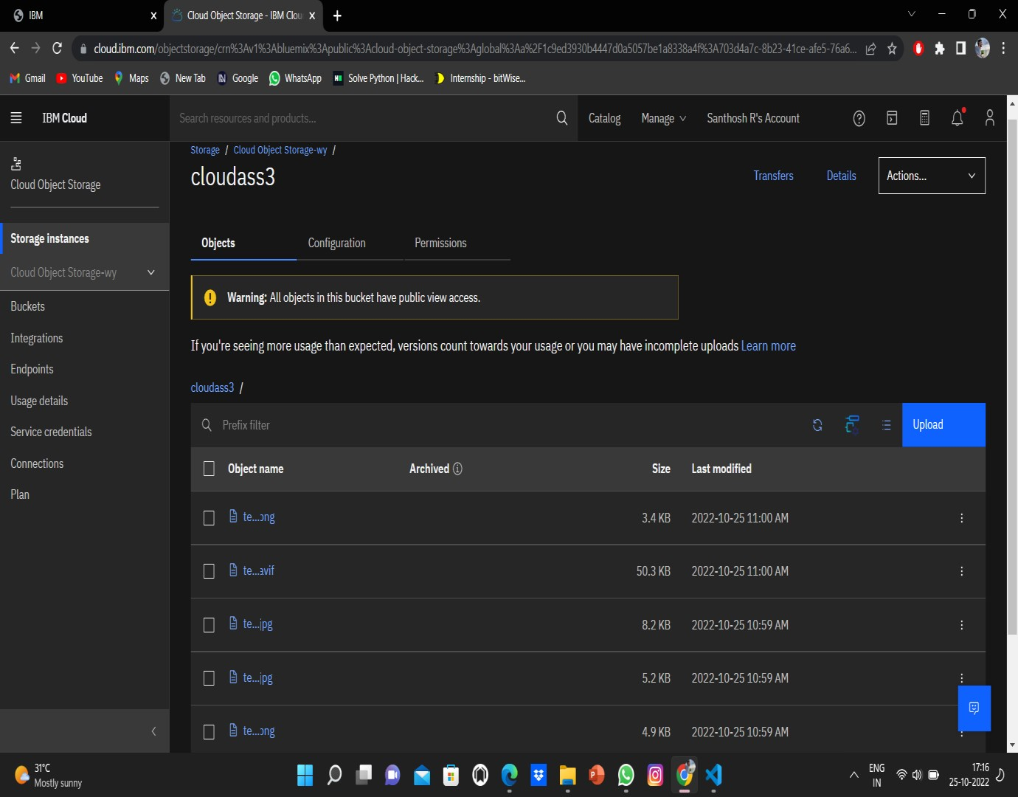

**Upload 5 images to IBM object storage and make it public. write html code todisplaying all the 5 images:**

**Html code**

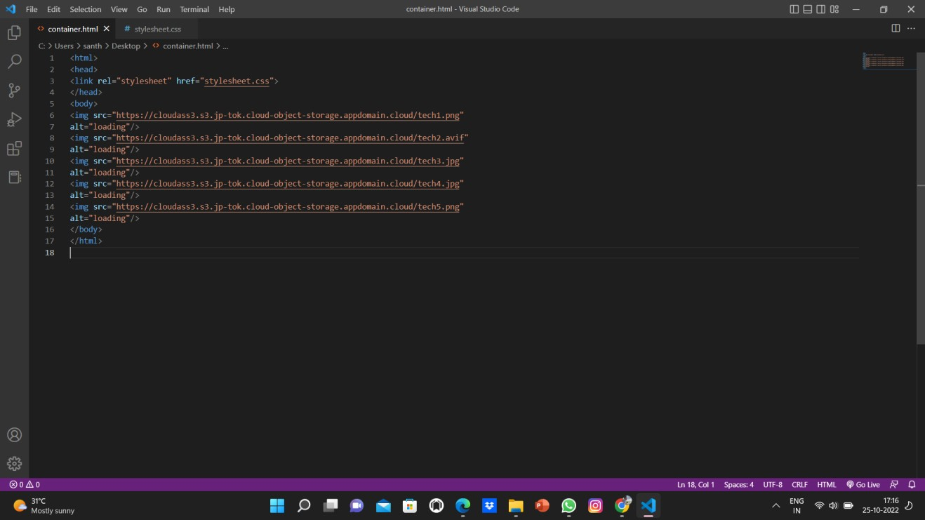

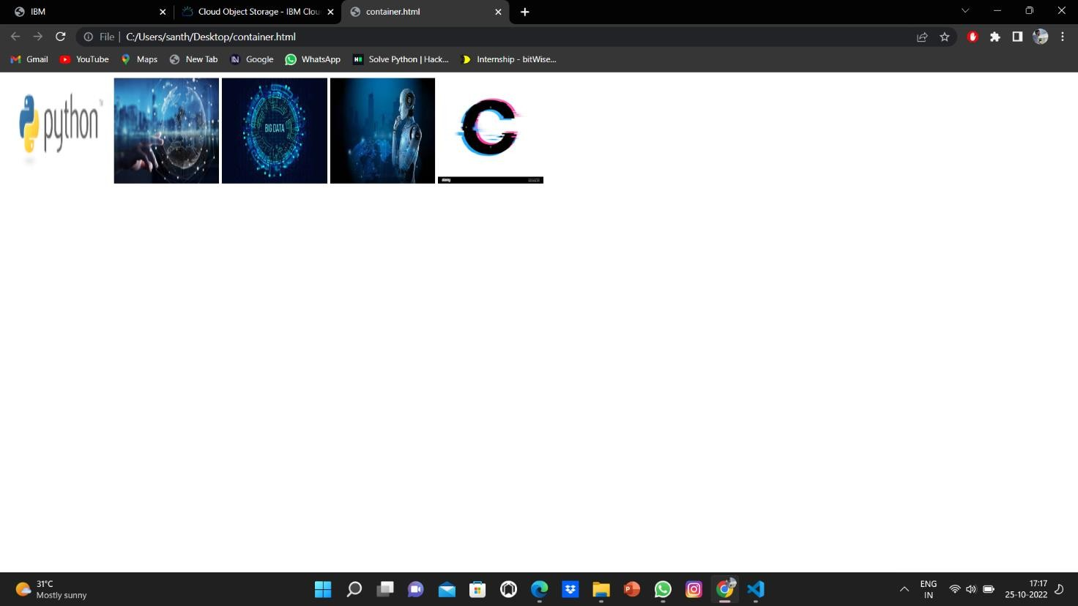

# Upload a css style sheet to the object storage and use the same page in your HTML

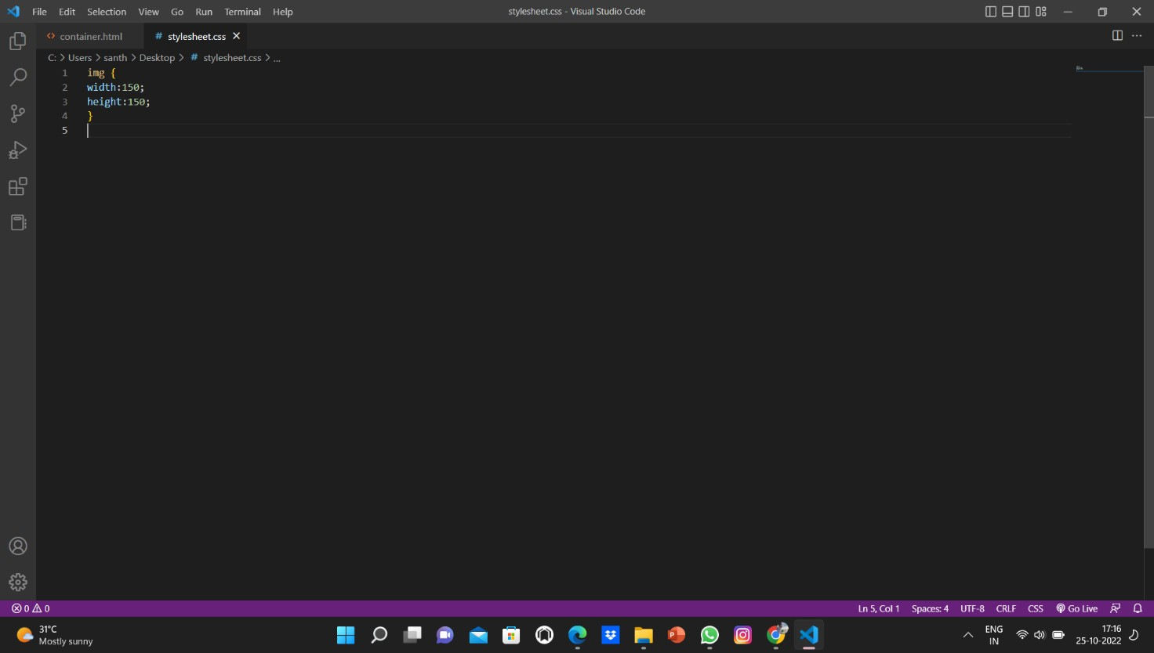



**Design a chatbot using IBM Watson assistant for hospital. Ex: User comes with query to know the branches for that hospital in your city.**

https://web- chat.global.assistant.watson.appdomain.cloud/preview.html?backgroundImageURL=https%3A%2F%2Fau- syd.assistant.watson.cloud.ibm.com%2Fpublic%2Fimages%2Fupx-dfb3f199-8e01-4848-8cfd- 4f6b86422e69%3A%3A52670bd3-1b34-4281-b998-ae5dc839a6b1&integrationID=b453177e-c112-4e93- a2b8-49a88e512efb&region=au-syd&serviceInstanceID=dfb3f199-8e01-4848-8cfd-4f6b86422e69

# Create Watson assistant service with 10 steps and use 3 conditions in it. Load that script in HTML page.

